Costa Rican Bulk Rock Compositions

Julie M. Coulombe

4/1/2020

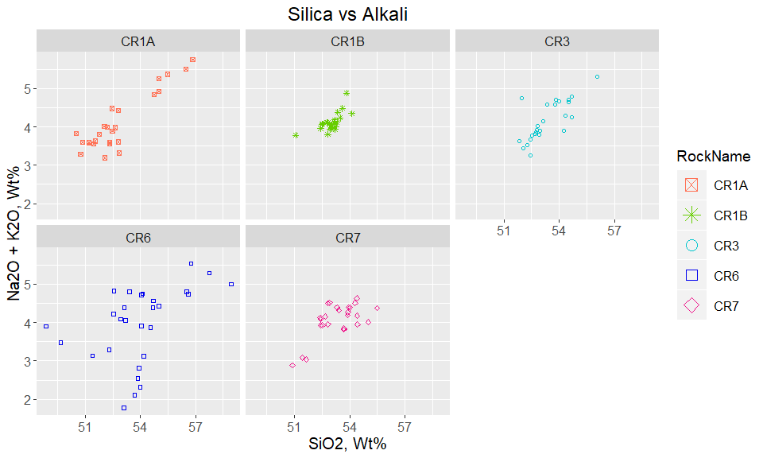

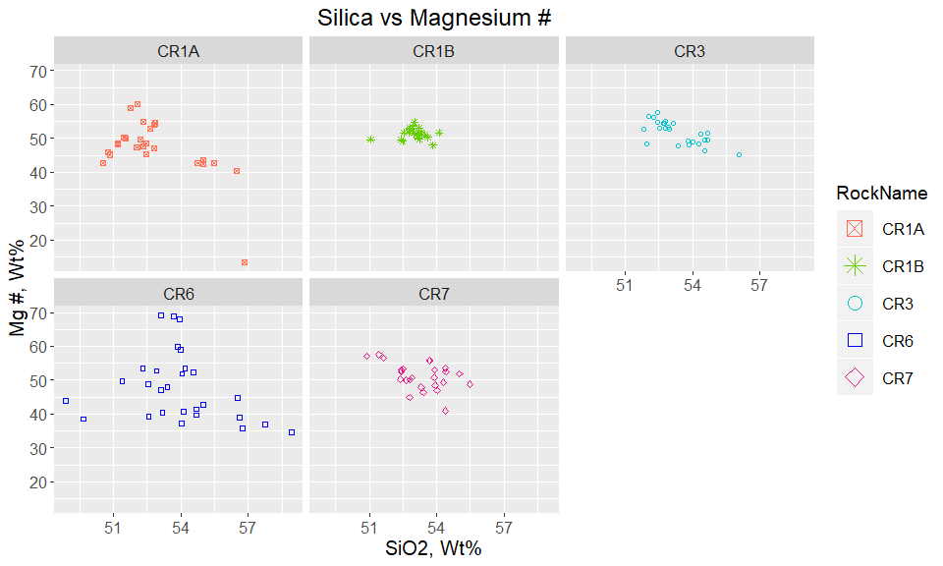

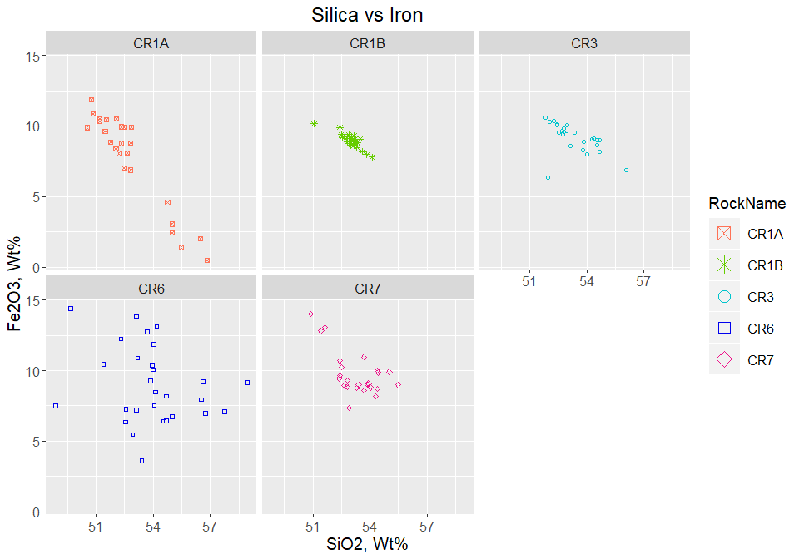

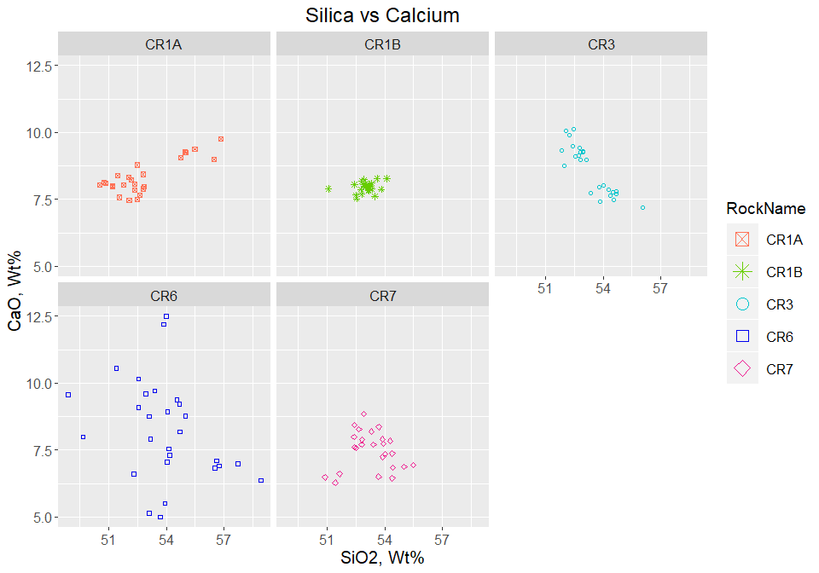

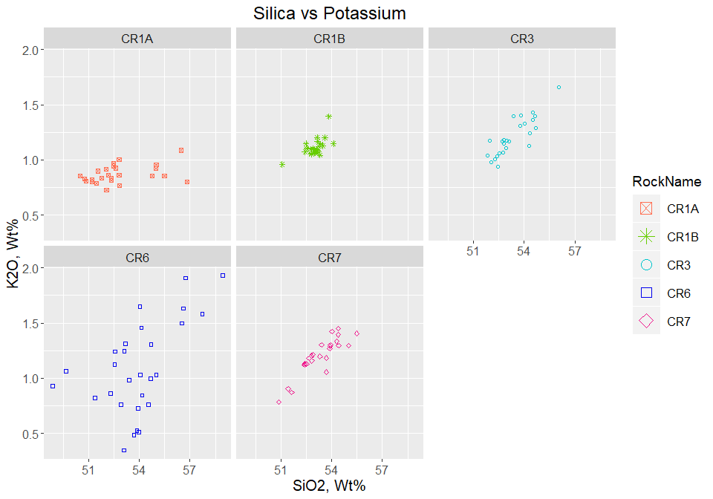

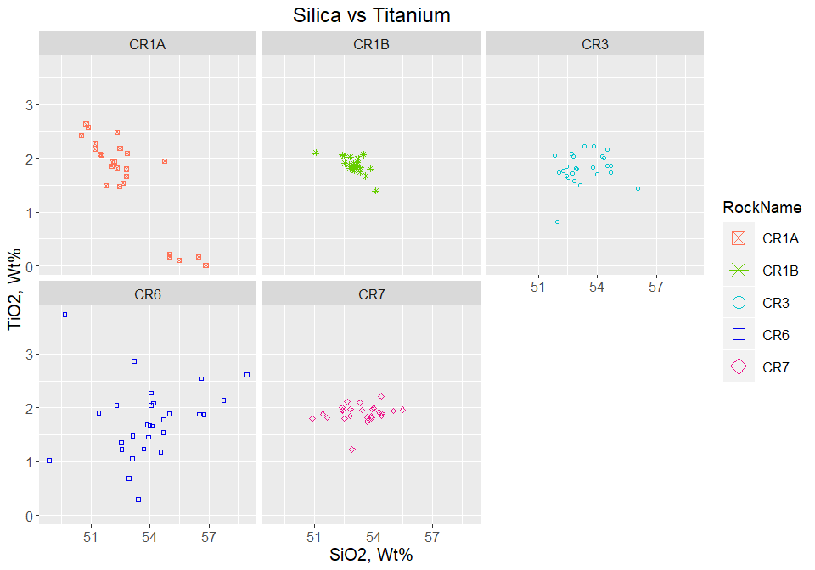

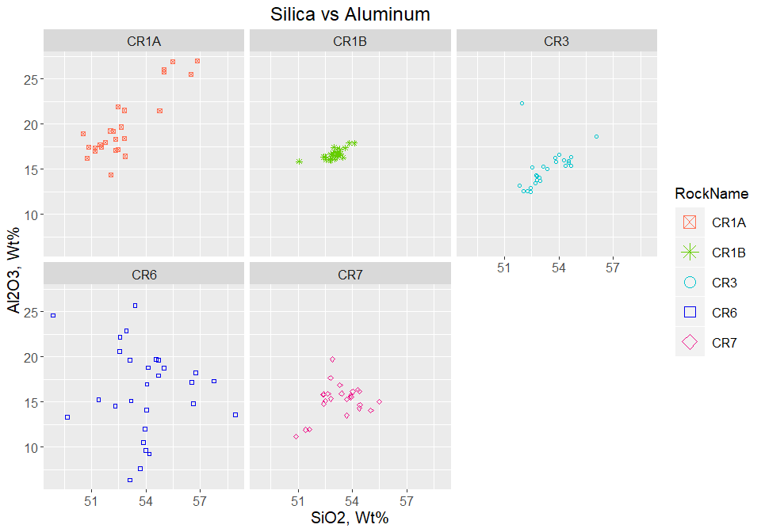

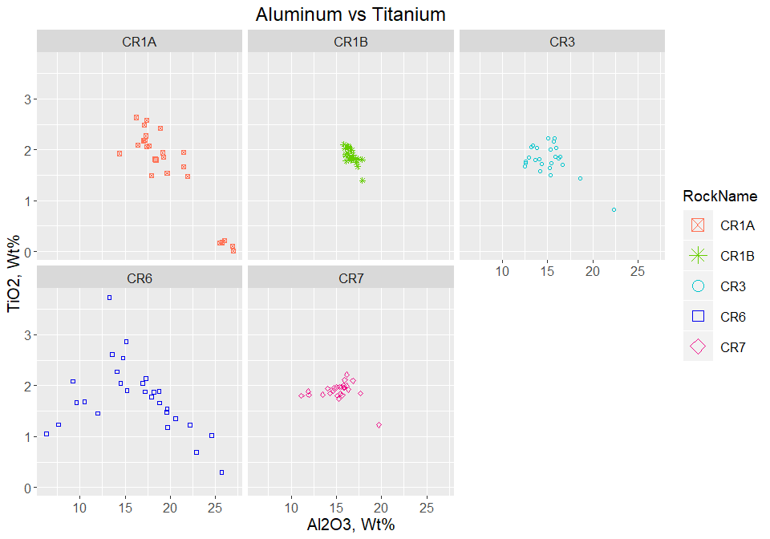

Plot Alkali by Rock Name - Bulk Composition 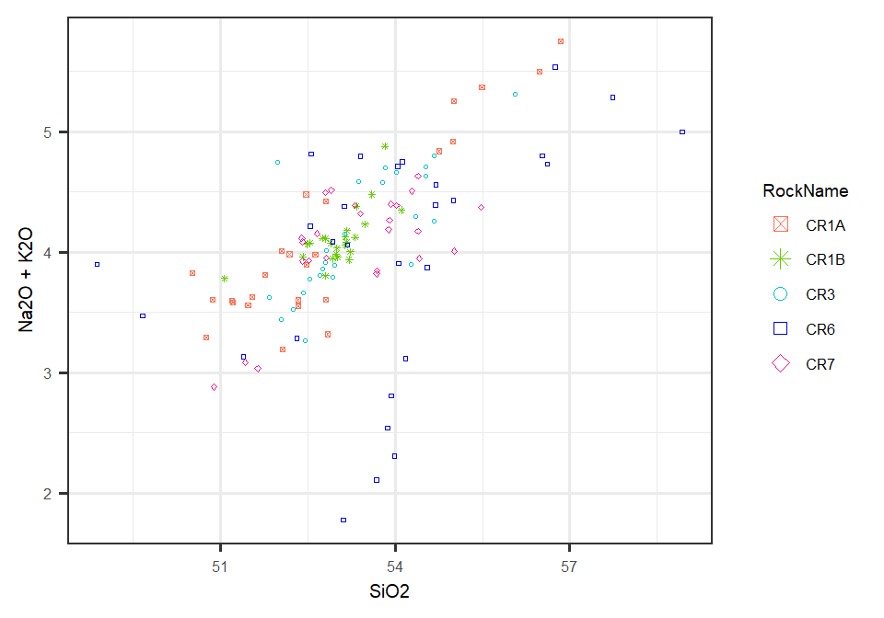

Overlay Alkali Plot on TAS Diagram 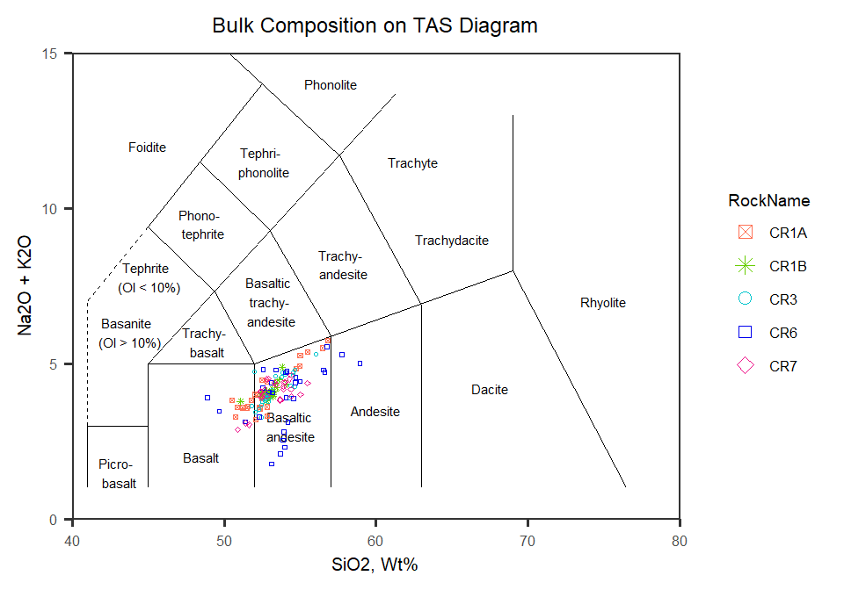

Now to look at plots of all rocks together

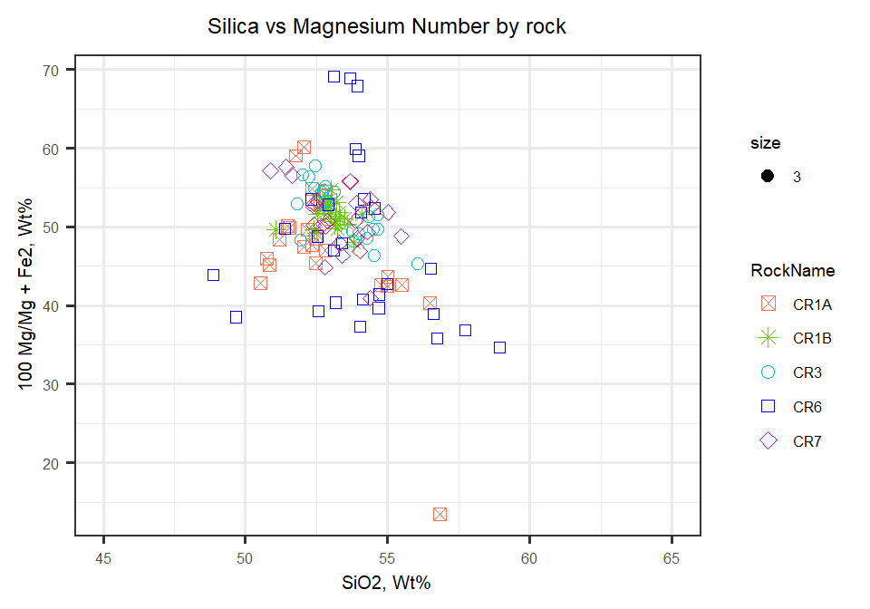

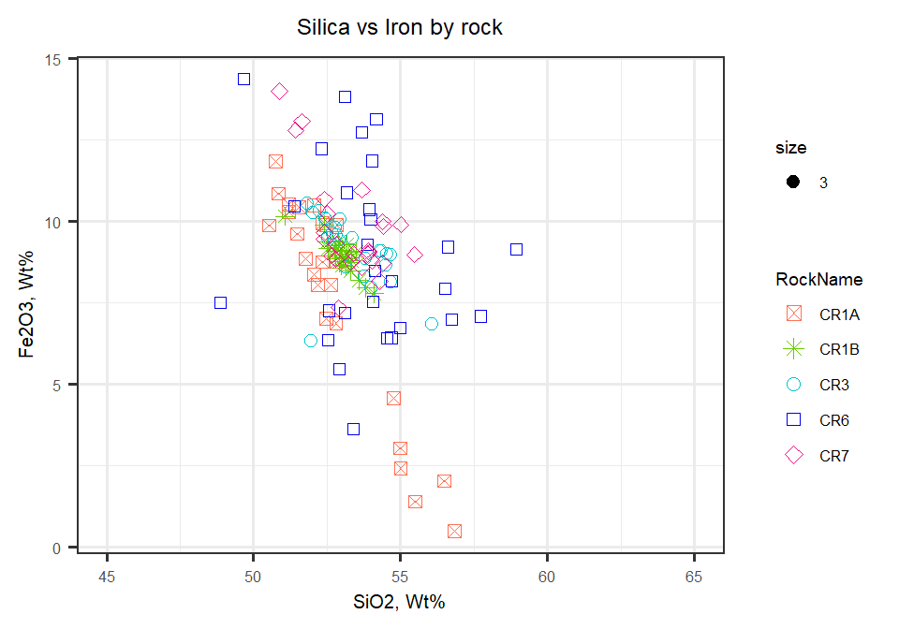

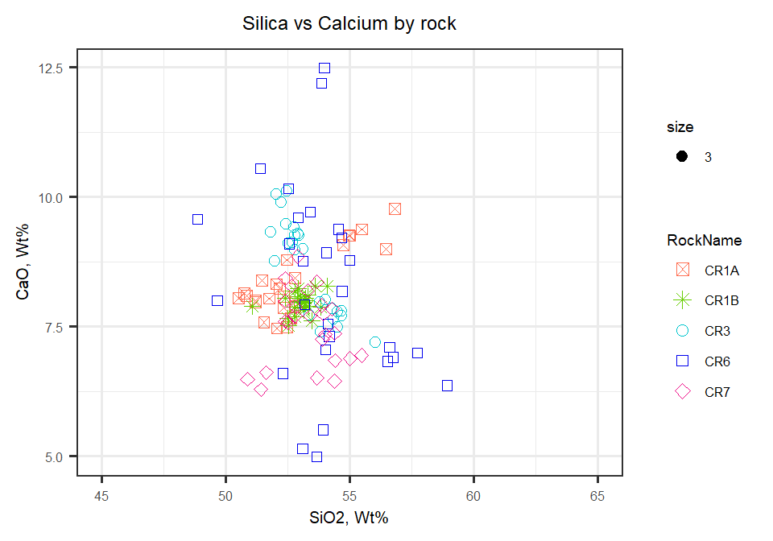

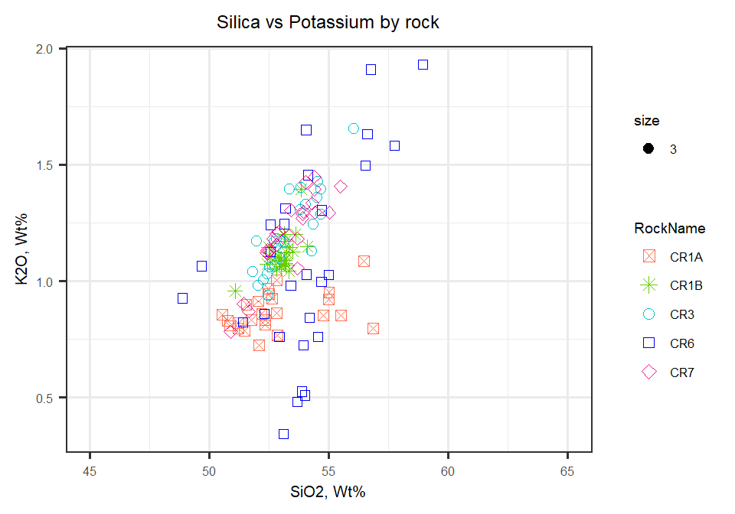

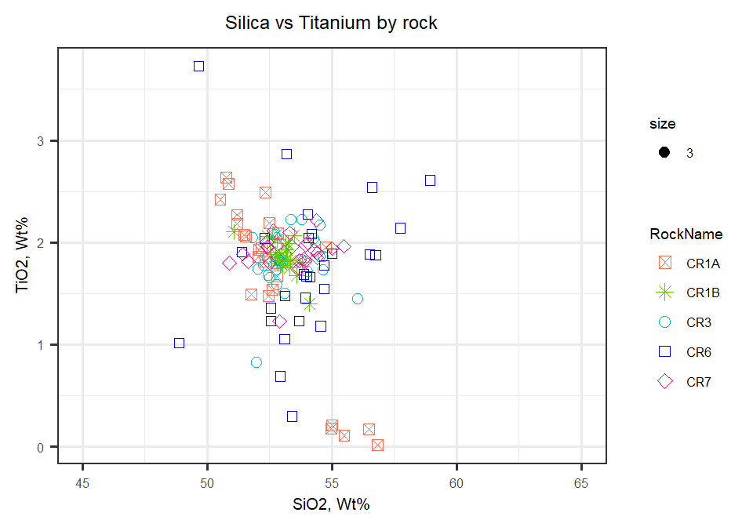

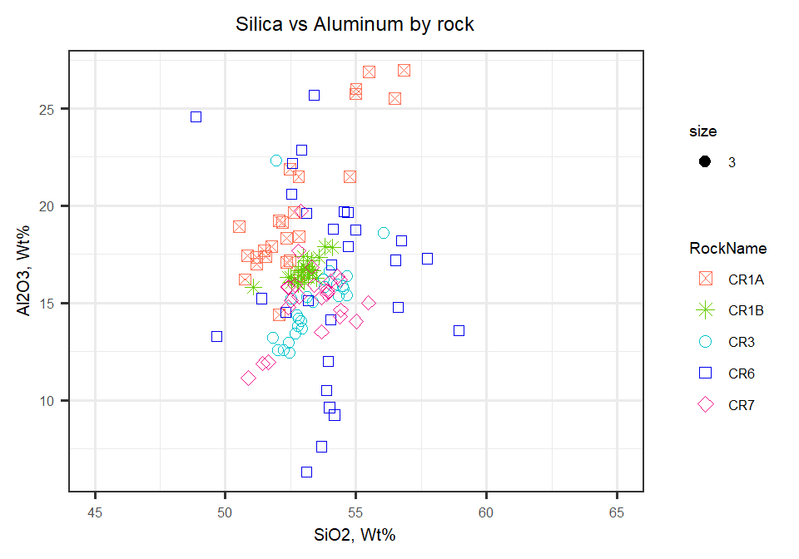

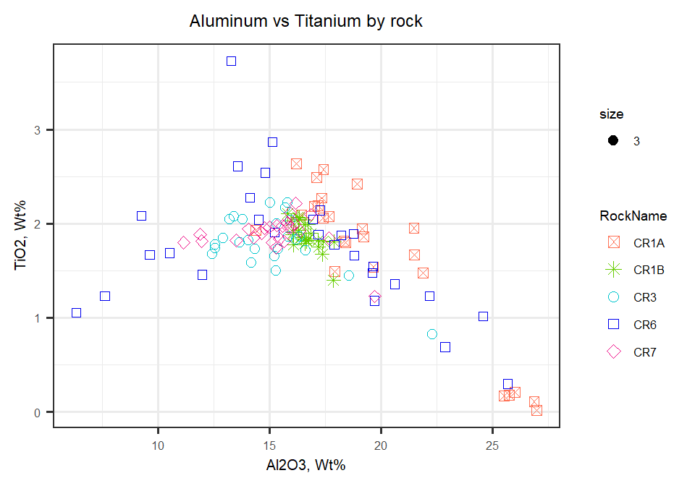

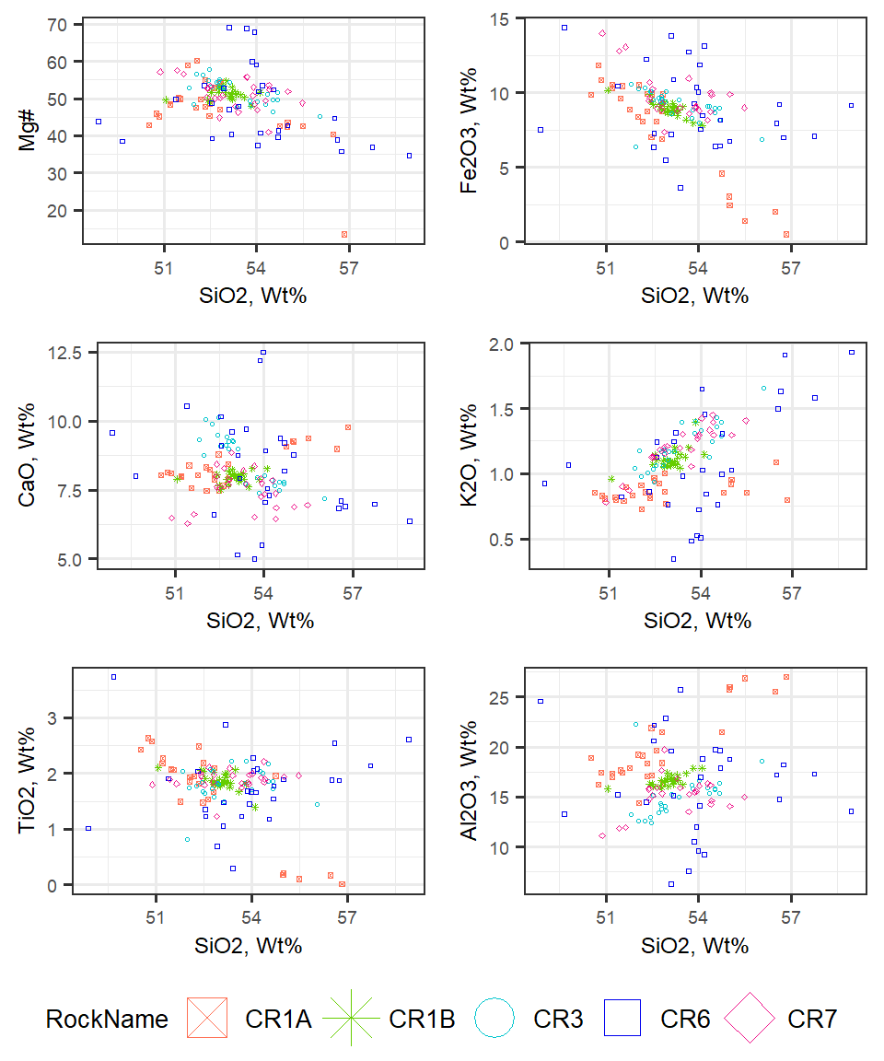

Now to compare CR1A to CR1B Harker Diagrams  
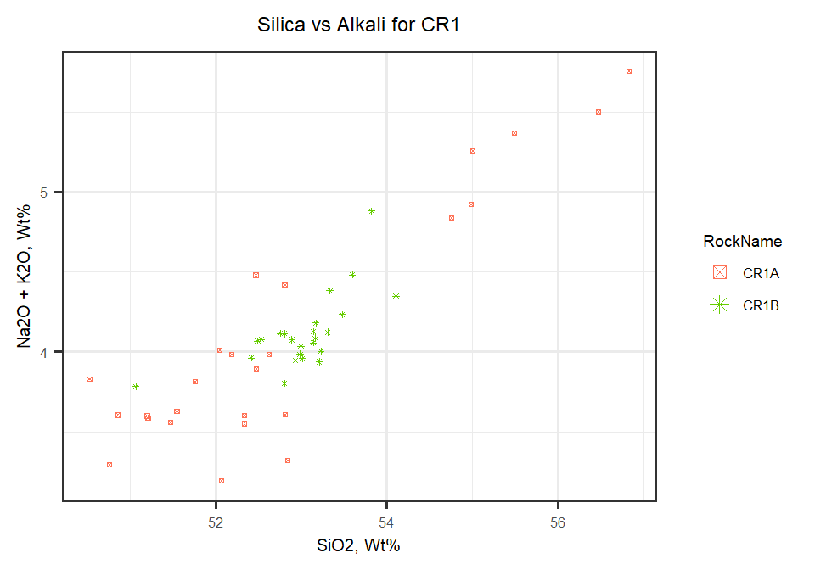

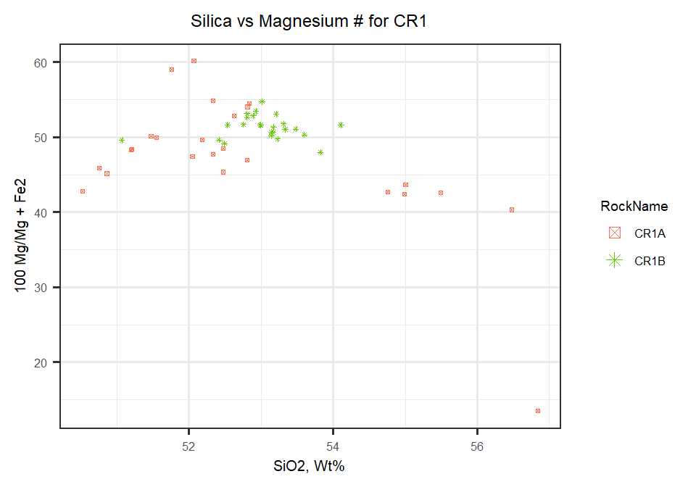

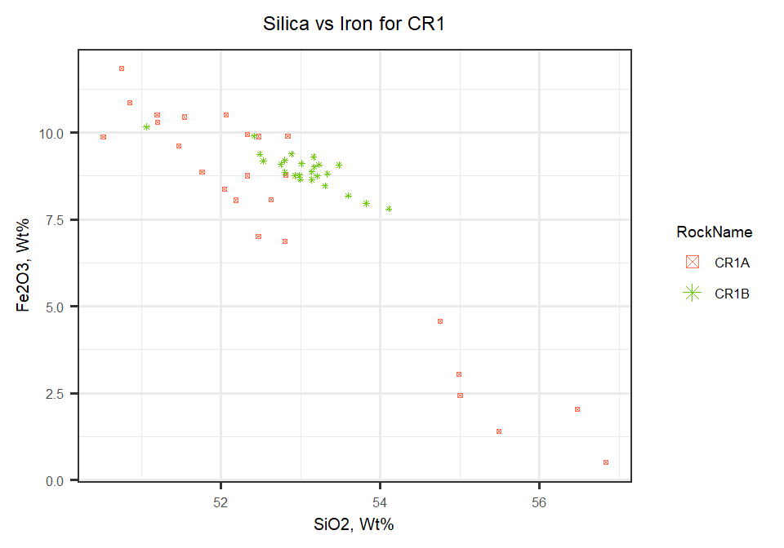

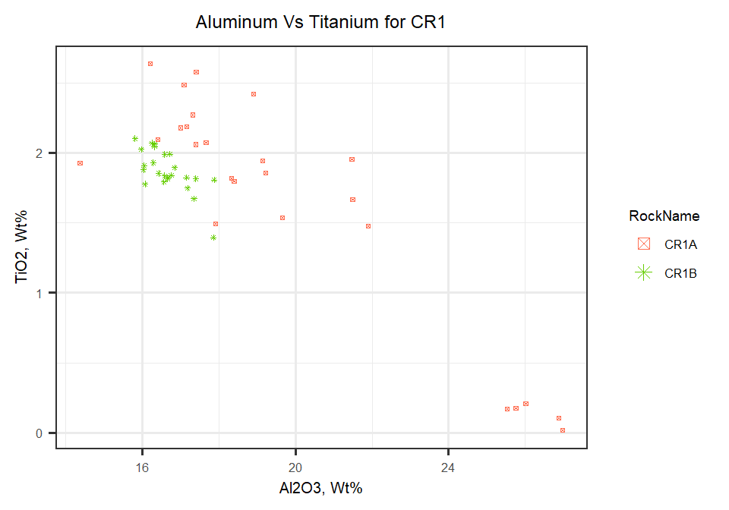

Taking a look at comparing CR2A to CR2B in Bulk Composition (bulk data for CR2 not yet available)

Table indicating mean averages for elements by rock

|  |  |  |  |  |  |  |
| --- | --- | --- | --- | --- | --- | --- |
| **RockName** | **P2O5** | **SiO2** | **TiO2** | **Al2O3** | **Cr** | **MgO** |
| CR1A | 0.302 | 52.8 | 1.64 | 19.8 | 0.0311 | 4.32 |
| CR1B | 0.349 | 53 | 1.87 | 16.7 | 0.0264 | 5.29 |
| CR3 | 0.346 | 53.3 | 1.81 | 15.1 | 0.0285 | 5.59 |
| CR6 | 0.301 | 53.9 | 1.76 | 16.3 | 0.0322 | 5.33 |
| CR7 | 0.349 | 53.3 | 1.9 | 15.2 | 0.0261 | 5.88 |
| **RockName** | **CaO** | **MnO** | **Fe2O3** | **Na2O** | **K2O** | **S** | **Total** |
| CR1A | 8.33 | 0.11 | 7.7 | 3.24 | 0.868 | 0.00635 | 99.3 |
| CR1B | 7.95 | 0.147 | 8.93 | 3 | 1.11 | 0.00881 | 98.8 |
| CR3 | 8.62 | 0.162 | 9.12 | 2.95 | 1.21 | 0.00736 | 98.9 |
| CR6 | 8.24 | 0.158 | 8.95 | 2.87 | 1.09 | 0.00902 | 99.1 |
| CR7 | 7.48 | 0.168 | 9.73 | 2.86 | 1.2 | 0.00784 | 98.8 |